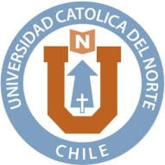
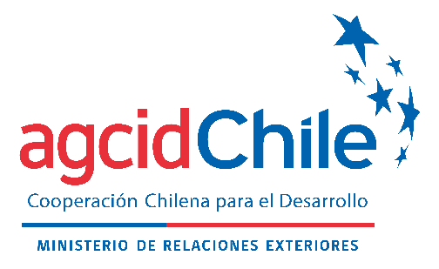

ANNEX II
COMMITMENT LETTER
South-South Cooperation Scholarship Program
AGCI - Universidad Católica del Norte

As an applicant to the International Course “Aquaculture Production Technologies and Use of Byproducts from Aquaculture and Fisheries, to be held by the Universidad Católica del Norte:
I, ______________________________________________________________

Applicant name

FROM_______________________________________________________________

Country of origin

I hereby declare that all the information provided is true and accurate, and if accepted, I hereby commit to follow these rules:
- Comply with the International Course Program.
- Accept all the conditions stipulated in relation to the Course.
- Observe the instructions given during the Course.
- Do not interrupt the International Course unless incapacitated due to a serious illness.
- Conduct knowledge sharing activities and implement my end-of-course project.
- In case of declining to participate in the International Course, if accepted, please reach out to the AGCI Focal Point at least five days prior to the beginning of the course, indicating the reasons of force majeure that compelled you to make this decision.

___________________ , __________ _______________, _______.
(Place (Day) (Month)

Applicant signature

